**Intune Detection**

The package will create a structure in registry:

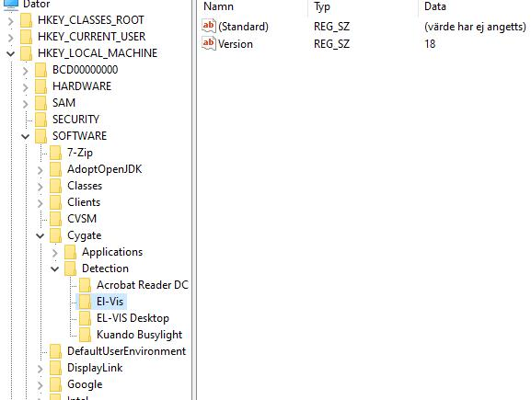

To detect if application (and version) is installed create a detection rule in Intune:

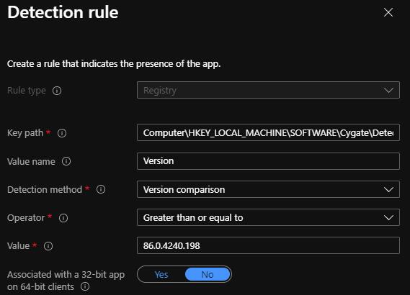

Where the key path is:

Computer\HKEY_LOCAL_MACHINE\SOFTWARE\Cygate\Detection\%Appname%

And version is: %appVersion% from PSAppdeploy script